# **Character Design**

## Deskorra(base)

Background:

Deskorra is a giant worm that have lived on planet Eklll for over a century. It can eat almost anything. It has the ability to dig through solid rocks and is able to swim through the acidic lakes on the surface of the planet unharmed. In the Zerg world, Deskorra is considered the leader on the planet. It can split parts of itself and have it morph into other Zerg lifeforms and it also creates tunnels and creeps for other Zergs to live in.  
  
In game:

In the defense of Tartarus VII mission (and optional in some later missions that’s part of the Abyssal Legacy campaign), Deskorra is considered a Zerg commander story-wise and the Zerg hive(base) gameplay-wise.

Unlike conventional Zerg hives, Deskorra heals over time and spawn units using its health points. Three additional hero units(Dostra, Nashanir and Elokia) that is unique to playing this commander can be spawned using this method.  
Player cannot build additional hive bases, but Deskorra can relocate itself to anywhere that have creep tumor on the map

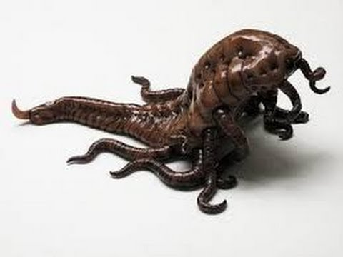

## Dostra (hero unit)

Dostra is a multi-leg creature spawned by Deskorra. It’s really fast in terms of both attack speed and movement speed. It attacks with the claws on its sides.

Skills:

String - a two hit attack, first a thrust/dash followed by a cone shaped slash.

String Upgrade - heals based on % damage dealt on second hit

Phase Shift - (must be on creep) leaves a piece of itself on the ground and teleports back to the piece on second time skill activation.

Phase Shift Upgrade - piece permanently in stealth, and Dostra temporarily in stealth.

Overall: fast, melee, assassin unit

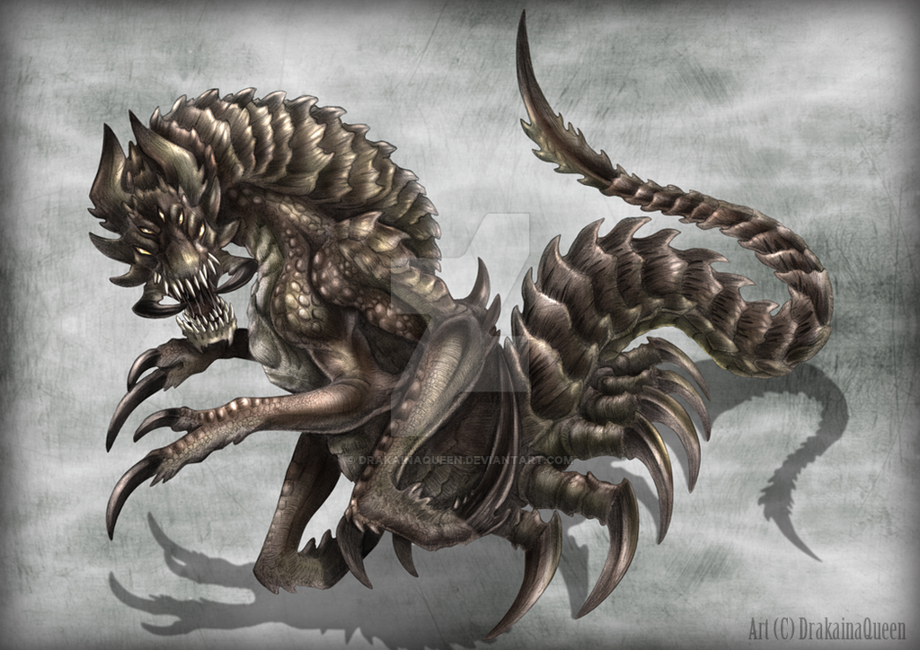

## Nashanir(hero unit)

Nashanir is a fish like flying creature spawned by Deskorra. It’s slow and cannot auto attack.

Skills:

Level 10 Earthquake - Nashanir becomes stationary and lands on the ground, dealing continuous damage to all structures in a range for 10 seconds. This skill can be canceled mid-way.

Level 10 Earthquake Upgrade - double the damage per second of the earthquake but the skill only last up to 5 seconds (basically, no net damage increase, just faster skill casting). Also, Nashanir gains a temporary defense buff during the skill.

Radiation Field - build a creep tumor that also deals continuous damage to all non-structure units in an area (excluding Neshanic and creep tumors)

Radiation Field Upgrade - no longer deal damage to friendly units

Overall: tower builder, siege unit

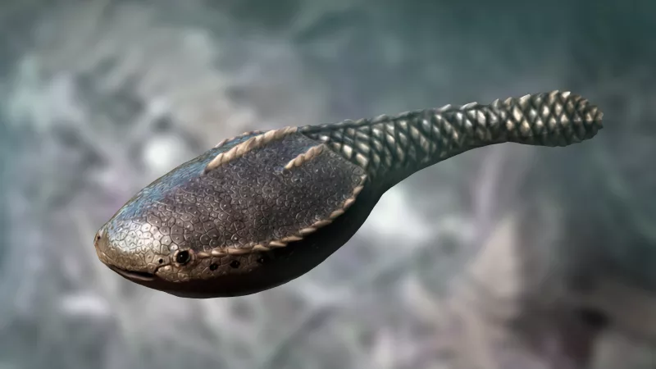

## Elokia(hero unit)

Elokia is a spider like flying creature spawned by Deskorra. It’s ranged and have decent speed on creep but drastically decrease when not on creep.

Skills:

Creep Web - create a one block wall that only friendly units can walk through  
Creep Web Upgrade - Increase wall health, and walls gains life regeneration

Guard Point - a powerful defense buff to all nearby friendly units for 3 seconds

Guard Point Upgrade - change the defense buff to damage immunity

Overall: wall builder, ranged, support unit

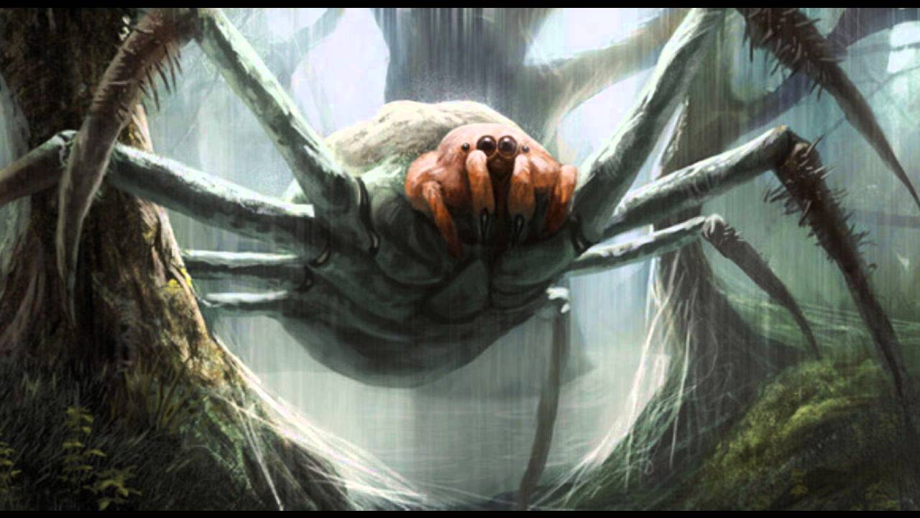

## Mutation Chamber (upgrade building)

Unlocks:

Deskorra’s ability to relocate

The six hero skill upgrades mentioned above  
Hero attack  
Hero defense